Smart Panel Lights

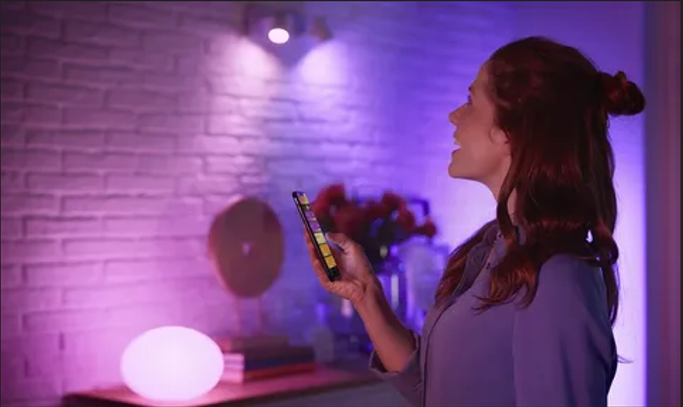

#### ****Description:****

**Smart Panel Lights** are sleek, energy-efficient lighting solutions designed to provide uniform and bright illumination for large spaces. These lights are perfect for offices, kitchens, living rooms, and other areas where consistent lighting is essential. With features like dimming, color temperature adjustment, and smart controls, Smart Panel Lights offer a modern and customizable lighting experience.

* **Technology:** Wi-Fi, Bluetooth, or Zigbee (depending on the model).
* **Compatibility:** Works with iOS and Android devices.
* **Panel Size:** 12x12 inches (30x30 cm) or 24x24 inches (60x60 cm).
* **Wattage:** 40W (equivalent to 200W incandescent).
* **Lumens:** 4000 lumens.
* **Color Temperature:** Adjustable white light (3000K-6500K).
* **Dimmable:** Yes.
* **Lifespan:** 50,000 hours.
* **Energy Efficiency:** Energy Star certified.
* **Control Options:** Mobile app, voice control (Alexa, Google Assistant, Apple HomeKit).

#### ****Key Features:****

* **Uniform Illumination:** Provides even and bright light distribution, ideal for large spaces.
* **Customizable Lighting:** Adjust brightness and color temperature to create the perfect ambiance.
* **Voice Control:** Compatible with Alexa, Google Assistant, and Apple HomeKit for hands-free control.
* **Energy-Efficient:** Uses up to 85% less energy than traditional incandescent bulbs.
* **Scheduling and Automation:** Set schedules, timers, and routines for automated lighting control.
* **Group Control:** Control multiple panels simultaneously for synchronized lighting.
* **Easy Installation:** Designed for simple ceiling mounting with included hardware.
* **Modern Design:** Slim and stylish, suitable for any modern decor.

#### ****Pricing:****

* **Single Panel (12x12 inches):** $99.99
* **Single Panel (24x24 inches):** $149.99
* **2-Pack (12x12 inches):** 179.99(179.99(90.00 per panel)
* **2-Pack (24x24 inches):** 279.99(279.99(140.00 per panel)

#### ****Where to Use:****

* **Offices:** Provide consistent and bright lighting for workspaces.
* **Kitchens:** Brighten up cooking and dining areas with adjustable white light.
* **Living Rooms:** Create a cozy or vibrant atmosphere with customizable lighting.
* **Classrooms:** Enhance focus and productivity with uniform illumination.
* **Retail Stores:** Highlight products with bright and energy-efficient lighting.

### ****Customer Reviews:****

* ⭐⭐⭐⭐⭐ "These Smart Panel Lights are amazing! They were super easy to install, and I love controlling them with my phone. The light is so bright and even." – Sarah L.
* ⭐⭐⭐⭐ "Great value for the price. The panels are bright, and the app is easy to use. Highly recommend for anyone looking to upgrade their lighting." – James T.
* ⭐⭐⭐⭐⭐ "I love how energy-efficient these panels are. The scheduling feature is a game-changer for my daily routine." – Emily R.

### ****How to Order:****

1. Visit our website: [www.brightworldlighting.com](http://www.brightworldlighting.com/)
2. Select your preferred panel size and pack size (Single or 2-Pack).
3. Add to cart and proceed to checkout.
4. Enjoy free shipping on all orders over $100!

### ****Warranty and Support:****

* **Warranty:** 2-year limited warranty covering manufacturing defects.
* **Customer Support:** Contact us at [support@brightworldlighting.com](mailto:support@brightworldlighting.com) or call +1-800-123-4567 for assistance.

### ****Visual Representation:****

Include high-quality images of the Smart Panel Lights in different settings (e.g., office, kitchen) to showcase their versatility and design.